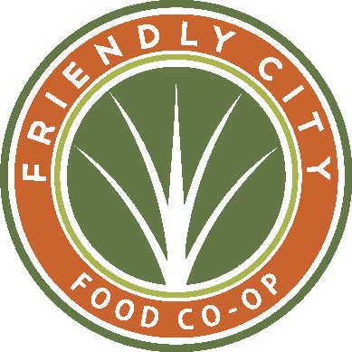 **Strategic Plan 2023 – 2026 True to our Roots, feeding our soil to strengthen our future**

| **OUR ENDS**  Shenandoah Valley has:   * Vibrant, local economy * Fair and friendly relationships * Healthy consumer and producers * And a healthy environment   **CO-OP PRINCIPLES**   * Voluntary & Open Membership * Democratic Member Control * Member Economic Participation * Autonomy & Independence * Education, training & information * Cooperation among co-ops * Concern for Community   **FOUNDATIONAL STRATEGIES**   * Grocer of choice, employer of choice, marketplace of choice. * Outstanding customer service * Balance fair prices for customers, fair wages for staff and fair prices to farmers. * Green business practices * Equity and Justice every day.   **BEHAVIORAL VALUES**   * Friendly * Learning organization * Set each other up for success * Collaborating for cooperative gain * Environmentally aware * Fun loving, passionate and positive | **MARKETING** | **PRODUCTS, SERVICES AND EXPERIENCES** | **TEAM**  **(Recruit, Train, Develop, Retain)** | **SYSTEMS** | **FINANCIAL AND INFRASTRUCTURE** |
| --- | --- | --- | --- | --- | --- |
| **Goals**  *June 2026*   * ***Community understands co-ops, organic, local*** * ***Teach it, promote it, Advocate for it, sample it, talk about it, Normalize it.*** | **Goals**  *June 2026*   * ***Lean into brand – local, organic, nutrient dense*** * ***Convenient, approachable, understandable, accessible*** | **Goals**  *June 2026*   * ***Learning organization with deeper support for all*** * ***Build bridges to break down barriers*** | **Goals**  *June 2026*   * ***Standardize Data integrity*** * ***Evolve away from paper based*** * ***Systems integration*** | **Goals**  *June 2026*   * ***Grow sales to $8M*** * ***Maintain growth and freshness of expanded space*** |
| **🡻** | **🡻** | **🡻** | **🡻** | **🡻** |
| **Strategies**  *By June 2024*   * *Promote the co-op glossary of terms – Co-op, Local, Organic* * *Clarify and share Round up guidelines* * *Refresh exterior branding – window vinyl, pylon sign* * *Explore New advertising avenues* * *Website ADA compliant - refreshed* | ***Strategies***  *By June 2024*   * *Next level customer service every day* * *Deli Bakery execution & program is expanding, appealing, seasonal* * *Focus on fresh departments: meat, cheese, bakery, produce.* * *Regenerate sampling and demos* * *Implement NCG core sets* * *Good, better, best pricing* * *Year-round garden center* | **Strategies**  *By June 2024*   * *Develop redundancy for key roles. Cross departmental support* * *Create more opportunity for growth* * Communications streamlined – one schedule, one info stream * *Exciting, bite sized, memorable training programs* * *Highlight benefits* * *Clear evaluation process, timing* * *Emergency Preparedness manual* | **Strategies**  *By June 2024*   * *IT systems foster communication and productivity* * *Naming conventions for all depts.* * *Streamline internal communications* * *Owner data cleaned up and standards clarified* | **Strategies**  *By June 2024*   * *Grow sales to $7.8M ($8M by 2026)* * *Stay profitable* * *Credit card processing thru UNFI* * *Balance labor costs and margins* * *Repair damaged walls* * *Clean up/maintain oxidized produce case* |
| **🡻** | **🡻** | **🡻** | **🡻** | **🡻** |
| ***2024 Metrics***   * ***Customer Count to 20k/month*** * *New Owners >20 per month* * *>10% of active owners voting* * *Click throughs from social increase* | ***2024 Metrics***   * ***Deli & Bakery Sales to $25k/wk.*** * *Margins >35.0%* * *Average basket >$35* | **2024 Metrics**   * **Wage % <21%** *(18% Ops, 3% Admin Support)* * *Turnover <20%* * *Diversity of staff closer to that of Harrisonburg* | **2024 Metrics**   * *Owner data cleaned up* * *POS data organized* * *Managers and buyers know which reports to use for best data* * *Reliable data for ownership metrics* | **2024 Metrics**   * **Sales to $150k/wk. *(****$7.8M annualized)* * **Net Income >1%** |